CHAPTER ONE

INTRODUCTION

1.1 Background to the Study
The continuous advancement of information and communication technology (ICT) has led to the automation of service delivery processes across educational institutions worldwide. Universities are increasingly adopting digital systems to improve efficiency, transparency, and user satisfaction. At the Federal University Otuoke (FUO), Bayelsa State, food services constitute a critical aspect of daily campus life for students, academic staff, and non-academic staff. Despite the presence of several food vendors within the FUO campus, food ordering and service delivery are predominantly carried out through manual procedures. Customers are required to visit food outlets physically, examine available food options on-site, place orders verbally, and make payments using cash. This approach often results in operational inefficiencies such as long queues, extended waiting times, order inaccuracies, congestion around food outlets, and poor transaction records, particularly during peak periods such as lunch hours.
The absence of a centralized digital food ordering platform makes it difficult for students and staff to view available menus remotely, place orders conveniently, and receive timely food delivery services. It also prevents food vendors from managing customer orders efficiently, often resulting in delays, order inaccuracies, and poor record management. Furthermore, the continued reliance on cash payments increases security risks such as theft and loss of funds while limiting transaction transparency and accountability. Traditional campus food service operations are also characterized by long queues, extended waiting times, and inefficient manual ordering procedures, which reduce customer satisfaction and negatively affect productivity.
The implementation of an online campus food ordering and delivery system can significantly improve the efficiency of campus dining services. Such a system enables users to browse digital menus, place orders, make secure online payments using credit or debit cards, and monitor the status of their orders through a web or mobile platform. These features reduce waiting time, improve order accuracy, and enhance the overall user experience while enabling vendors to manage orders more effectively (Davis, 1989; Kimes, 2011).
Another important benefit of an online campus food ordering and delivery system is its ability to provide personalized services. In future phases, users could choose meals based on their dietary preferences, nutritional requirements, and allergies. The system could also maintain customer order histories to generate personalized meal recommendations, promotional offers, and loyalty rewards based on previous purchases (note: these advanced features are currently planned for future iterations and are not implemented in the current version). Personalization enhances users' perceived usefulness of the system, improves satisfaction, and encourages continued use of the platform (Venkatesh et al., 2003).

The successful design and implementation of an online campus food ordering and delivery system require seamless integration with existing campus infrastructure and effective collaboration among stakeholders. This includes integrating secure online payment gateways, coordinating food preparation and delivery processes, and ensuring compatibility with existing campus information systems where applicable. Effective collaboration between educational institutions, food vendors, and technology providers enhances operational efficiency, improves service delivery, and supports the long-term sustainability of the system (Laudon & Laudon, 2022; Kimes, 2011).
Another important consideration in developing an online campus food ordering and delivery system is ensuring accessibility and inclusivity for all users, including individuals with disabilities. The system should comply with recognized web accessibility standards by prioritizing readable interface designs, appropriate color contrast, and standard browser compatibility, with advanced keyboard navigation and screen reader support planned for future releases.. These accessibility features enable users with diverse abilities to access and use the system effectively, promoting equal access to campus dining services. Designing accessible digital platforms also demonstrates an institution's commitment to diversity, inclusion, and equal opportunities for all users (EDUCAUSE, 2020; W3C, 2023).
An Online Campus Food Ordering and Delivery System with integrated electronic payment provides a technological solution to these challenges. The system utilizes web-based technologies to enable authenticated FUO campus users to browse food menus, submit orders electronically, complete secure debit card payments, and receive their meals through a coordinated delivery mechanism within the university environment.

1.2 Statement of the Problem
The manual, cash reliant food ordering system at Federal University Otuoke creates significant service inefficiencies, leading to prolonged wait times, order inaccuracies from verbal miscommunication, and operational challenges for vendors in record-keeping and coordination. These issues underscore the urgent need for a centralized, automated online food ordering and delivery platform that integrates secure electronic payments and real time order management and tracking. Importantly, the design of such a system must prioritize universal accessibility focusing on standard web accessibility practices to ensure an equitable and inclusive dining experience for all members of the campus community (dedicated screen-reader compatibility and custom keyboard navigation layouts are planned for future versions)., thereby transforming service delivery and reinforcing institutional commitment to diversity.
1.3 Aim and Objectives of the Study
The Aim and objective of the study is to examine Design and Implementation of an online campus food ordering and delivery system for the use at Federal University Otuoke. Specific objectives of the study are
- Design a centralized online platform for food ordering in FUO school canteen
- Design a secure management information system not prone to internal and external attacks.
- Provide real-time order tracking and delivery management features
- Improve service efficiency and reduce congestion at campus food outlets
1.4 Significance of the Study
This study and the proposed system hold substantial significance for multiple stakeholders within the campus ecosystem, addressing operational inefficiencies and contributing to the digital transformation of campus services.
      - For Students: The system enhances user experience by eliminating queues and enabling cashless transactions, saving valuable time and reducing decision-making uncertainty. This aligns with research showing that digital ordering systems significantly increase perceived convenience and satisfaction by minimizing wait times and effort Furthermore, cashless systems align with modern payment preferences and enhance transaction security on campus.
      - Non Teaching Staff: This system helps non teaching staff to save time and reduce the stress of going out to buy food during work hours . They can easily order meals and have them delivered to their offices. Overall, it improves their daily work experience and makes their routine more convenient.
      - Teaching Staff: Teaching staff can quickly order food without interrupting lectures, meetings, or research work. It helps them manage their tight schedules better and stay energized throughout the day.
1.5 Scope of the Study
The study is concerned with the design and development of a web-based online food ordering system that incorporates card payment functionally for use within Federal University Otuoke. The system is intended to provide a digital platform through which students, staffs, and other users within the university can conveniently view food options and place orders online without the need for physical interaction with the restaurant.
The system is designed to enable users to create personal account, log into the platform, and access a digital menu displaying the available food items. Through the interface, users can select their preferred meals and submit orders electronically. In addition to the ordering feature, the system integrates a secure card payment option that allows customers to complete transaction debit or credit card directly on the platform. This integration is aimed at ensuring a smooth and reliable payment process that connects food selection with immediate payment confirmation.
Another important aspect of the system is the administrative module, which develops to assist restaurant managers or administrators in handling the operational activities of the platform. Through this module, administrators are able to add, modify, or remove food items from the menu, monitor customer orders, and manage relevant user information. This administrative functionality supports efficient coordination of orders and improves the overall management of the food service process.
The scope of this study is limited to the core components necessary for the effective operation of an online food ordering platform. Emphasis is placed on system design, user registration and authentication, menu browsing, order placement, payment processing, and administrative management features. These elements represents the fundamental processes required for afunctional and practical online ordering environment.
However, certain advanced functionalities are deliberately excluded from this project. For instance, features such as real-time GPS tracking for food delivery, management of delivery riders, and automated push notification system are not considered within the boundaries of this study.
1.6 Limitations of the Study
The major limitations of the research study are time, financial constraints and delays from respondents. The researcher had difficulties combining lectures with field work. Financial constraints in form of getting adequate funds and sponsors to print questionnaires, hold Focus group discussions and logistics was recorded. Finally, respondents were a bit reluctant in filling questionnaires and submitting them on time. This delayed the project work a bit.
1.7 Definition of Terms
- Administrator: An authorized user responsible for managing food items, users, orders, and overall system operations.
- Delivery Personnel (Offline Process): Delivery operations (delivering ordered food items from the restaurant to the customer's faculty) are handled offline manually by the canteens; there is no dedicated delivery rider account or management module in the current system.
- Card Integration: The incorporation of debit or credit card payment functionality into the system using a payment gateway to enable secure online transactions.
- Authentication: The process of verifying a user’s identity before granting access to the system.
- Database: A structured collection of data used to store user information, food menus, orders, and transaction records.
- Authorization: The assignment of access rights and permissions to users based on their roles within the system.
- Transaction: A financial operation carried out through the system, such as payment for ordered food items.
- Security: Measures implemented to protect user data, payment information, and system resources from unauthorized access.
- Menu Management: The process of creating, updating, and managing the digital menus offered by campus dining facilities within the online ordering system. Menu management involves categorizing food items, setting prices, specifying descriptions and ingredients, and incorporating images to provide users with comprehensive and visually appealing menu options.
- Payment Gateway: A secure online platform integrated into the online campus food ordering and delivery system to facilitate electronic payment transactions. Payment gateways enable users to securely enter payment information, such as credit card details or digital wallet credentials, and process payments for their food orders in real-time.

CHAPTER TWO
REVIEW OF RELATED LITERATURE
2.1. Online Food Ordering System
An online food ordering system is a web- or mobile-based platform that enables customers to browse restaurant menus, place orders, make payments, and track deliveries in real time (Laudon & Laudon, 2022; Turban et al., 2018).
To understand this concept clearly, imagine a traditional market. You walk in, find a seller, negotiate a price, pay cash, and carry your purchase home. An online food ordering system is like that market, but digital. You "walk in" by opening the website, "find a seller" by browsing the restaurant menu, "negotiate" by reading prices and selecting your quantity, "pay" using your credit card, and "carry home" means a delivery rider brings the food to you.
According to research studies, these systems have completely changed how people order food. What used to require physical presence and cash now happens entirely through a smartphone screen. This shift has been especially impactful in educational environments where students have tight schedules, limited time for cooking, and often no access to kitchen facilities in hostels (Ray et al., 2019; EDUCAUSE, 2020).
Key Components of an Online Food Ordering System
Every online food ordering system is built from several essential parts that work together. Understanding these components helps us appreciate how the system functions as a whole (Turban et al., 2018).
User (Student) Interface
This is what the student sees and interacts with. It includes the home screen, menu display, shopping cart, and payment page. A good user interface should be simple, attractive, and easy to use even for someone who is not tech-savvy (Davis, 1989; Venkatesh et al., 2003).
Vendor (Restaurant/Canteen) Dashboard
This is the "back office" that restaurant or canteen owners use. When a student places an order, it appears on the vendor's dashboard. The vendor can accept or reject orders, update menu items, set prices, and mark orders as ready for delivery (Kimes, 2011; Laudon & Laudon, 2022).
Admin Panel
This is controlled by the system administrator (often the university's IT department or the company running the platform). The admin can manage vendors, resolve disputes, view reports, and ensure the system is running smoothly (Laudon & Laudon, 2022).
Payment Gateway Integration
This is the secure technology that processes payments. When a student enters their credit card details, the payment gateway encrypts the information, communicates with the bank, and confirms whether the payment was successful or declined (PCI Security Standards Council [PCI SSC], 2022).
Real-Time Order Tracking and Delivery Management
After placing an order, students want to know where their food is. This component uses manual status updates from the kitchen dashboard to show the progress of an order (real-time GPS tracking is not implemented in the current system).: "Order Received," "Being Prepared," "Out for Delivery," and "Delivered" (Ray et al., 2019; Kimes, 2011).

2.1.1 Web-Based Food Ordering Systems
A web-based food ordering system is one that runs in an internet browser such as Google Chrome, Mozilla Firefox, or Safari. Unlike a mobile app that must be downloaded and installed on a phone, a web-based system can be accessed by simply typing a web address (URL) into any browser on any device a laptop, tablet, or smartphone.
As stated by Kimes (2011), convenience and control are the primary factors motivating customers to use electronic ordering systems. Customers value the ability to determine when and where they place their orders, as well as the opportunity to customize their purchases according to their preferences. This further explains that advances in online and mobile technologies have transformed the restaurant industry by improving customer access to ordering services and enhancing operational efficiency.
In the context of this study, these findings support the adoption of a web-based food ordering system for students. Such a system enables users to place orders at their convenience, customize their meal selections, and access the service from any internet-enabled device. Since the system operates through a web browser, it can be accessed without installing a dedicated mobile application. Additionally, a mobile-responsive website ensures that the interface automatically adapts to different screen sizes, making the system accessible to students using smartphones, tablets, or desktop computers
2.1.2 Campus Food Delivery system
Campus food delivery systems are designed to address the unique needs of university communities by providing students with convenient access to meals within the campus environment. As stated by EDUCAUSE (2020), digital technologies are increasingly being adopted by higher education institutions to improve the accessibility and efficiency of student services. In this study, the proposed system is designed specifically for campus use by restricting deliveries to locations within the university premises, thereby reducing delivery time and simplifying navigation for delivery personnel. This approach also enhances convenience for students who may have limited time between lectures or prefer not to leave campus to obtain meals.
2.1.3 Credit Card Payment Integration
Credit card payment integration refers to the incorporation of a secure payment gateway that enables users to make electronic payments directly on a web application using payment cards such as Visa, MasterCard, and Verve. A payment gateway securely transmits transaction information between the customer, the merchant, and the issuing bank to authorize and process payments (Laudon & Laudon, 2022).
Electronic payment systems eliminate the need for cash-on-delivery (COD), reduce the risks associated with handling physical cash, and provide accurate digital records of financial transactions for both customers and merchants (Laudon & Laudon, 2022). In addition, digital payment systems improve transaction speed, convenience, and accountability, making them suitable for online food ordering platforms.
Payment gateways operate by securely encrypting card information and communicating with the customer's bank to verify the availability of funds before authorizing payment. Once the transaction is approved, the payment is transferred to the merchant, and both the customer and the merchant receive confirmation of the transaction (Turban, Pollard, & Wood, 2018).
The integration of electronic payment systems offers several benefits, including reduced dependence on physical cash, improved transaction transparency, easier refund processing, and enhanced protection against fraudulent activities through secure authentication and transaction monitoring (Laudon & Laudon, 2022).
To ensure the security of cardholder information, payment systems are required to comply with the Payment Card Industry Data Security Standard (PCI DSS), which specifies security requirements for storing, processing, and transmitting payment card data. Compliance with PCI DSS helps protect customers against data breaches and payment fraud (PCI Security Standards Council, 2022).

2.2 Review of Related Systems
Several online food ordering and delivery systems have been developed to improve the way customers order meals and how restaurants manage their services. These systems provide useful ideas and features that can be adopted when developing a campus food ordering and delivery system.
- Uber Eats, DoorDash, and Glovo
Uber Eats, DoorDash, and Glovo are among the most widely used online food delivery platforms globally. These platforms provide customers with features such as online menu browsing, electronic payment, order tracking, and customer feedback. As stated by Kimes (2011), advances in online ordering technologies have significantly improved customer convenience while enabling restaurants to increase operational efficiency. Similarly, (Ray et al., 2019) reported that the growth of online food delivery services has been driven by their convenience, ease of use, and ability to provide efficient and timely delivery services. However, these platforms are designed primarily for city-wide operations and may not be suitable for a university campus where delivery distances are relatively short and operational requirements differ.
- Jumia Food and Bolt Food
Jumia Food and Bolt Food are popular online food delivery platforms used in many African countries, including Nigeria. They support online ordering and electronic payment methods such as debit and credit cards, making food purchases faster and more convenient. Their success demonstrates the growing acceptance of digital food ordering systems in Africa. However, challenges such as internet connectivity, delivery efficiency, and secure payment processing continue to influence the quality of service provided.

- Campus Food Ordering Systems
Several web-based food ordering systems have been developed specifically for educational institutions. Most of these systems allow students to browse available meals, place orders online, and enable vendors to manage incoming orders through an administrative dashboard. While these systems improve the traditional manual ordering process, many do not provide advanced features such as real-time delivery tracking, integrated online card payment, or efficient delivery management within the campus environment.
Based on the reviewed systems, it is evident that an effective online food ordering platform should provide a simple user interface, secure electronic payment, efficient order processing, and reliable delivery services. These observations provide the basis for developing the proposed web-based campus food ordering and delivery system with integrated credit card payment. The proposed system is specifically designed to address the needs of students and food vendors within a university campus by providing a secure, convenient, and efficient ordering process.

CHAPTER THREE
SYSTEM ANALYSIS AND DESIGN
3.1 Methodology
The methodology adopted for the development of this Online Campus Food Ordering and Delivery System is the Software Development Life Cycle (SDLC) using the Waterfall Model. The Waterfall Model is a structured software development approach in which each phase is completed before the next phase begins. This approach was selected because the system requirements were clearly defined at the beginning of the project, making it suitable for a sequential development process (Pressman & Maxim, 2020).
The development of the system followed the stages outlined below:
- 1Requirements Gathering: Information was collected from prospective users, including students, food vendors, and system administrators, to identify the functional and non-functional requirements of the proposed system. The aim was to understand the challenges associated with the existing food ordering process and determine the features expected in the new system.
- System Analysis: The information gathered was analysed to identify the limitations of the existing method of ordering food on campus. This stage helped to define the system requirements and establish the objectives that the proposed system should achieve.
- System Design: Based on the analysed requirements, the overall structure of the system was designed. This included the database structure, system architecture, user interfaces, and the relationships between different system components.
- Implementation: The proposed system was developed using HTML, CSS, JavaScript (React) for the frontend, Node.js for the backend, and a NoSQL database for storing users, orders, payments, and other system records.
- Testing: After development, the system was tested to ensure that each module performed its intended function correctly. Testing also helped identify and correct errors before the system was made available for use.
- Deployment and Maintenance: Finally, the completed system was uploaded to a live cloud hosting service so that real students and vendors could access it from any device. The maintenance phase that follows deployment ensures the system stays working correctly over time and can be updated or improved in response to real-world feedback.
3.2 System Analysis
System analysis is the process of examining an existing system to understand how it operates, identify its strengths and weaknesses, and determine the requirements of a proposed system (Kendall & Kendall, 2019). The purpose of system analysis is to ensure that the developed solution effectively addresses the problems identified in the current system.
For this study, the existing method of ordering food on campus was analysed through observations and discussions with students and food vendors. The analysis revealed that the current process is largely manual, requiring students to visit food vendors physically before placing orders. This approach often results in long queues, increased waiting time, delayed service during peak periods, and inconvenience for students with tight lecture schedules.
The findings from the system analysis formed the basis for designing the proposed Online Campus Food Ordering and Delivery System, which provides online ordering, secure electronic payment, efficient order management, and improved service delivery within the university environment.
3.2.1 Analysis of the Existing System
The existing method of ordering food on campus is predominantly manual and relies on direct interaction between students and food vendors. There is currently no centralized online platform that allows students to browse available meals, place orders remotely, or make electronic payments before collecting or receiving their food.
Under the existing process, a student who wishes to purchase food must physically visit a cafeteria or food vendor within the campus. After arriving at the food outlet, the student checks the available meals either by viewing the displayed menu or by making verbal enquiries. Once a meal is selected, the order is communicated verbally to the vendor, who begins preparing the food. During busy periods, students are often required to wait in queues before their orders are processed. Payment is usually made in cash at the point of collection.
Although this method is simple to operate, it presents several limitations. Students may spend considerable time walking to food outlets, waiting for food preparation, and standing in queues, especially during lecture breaks when demand is high. Furthermore, the absence of an electronic ordering system makes it difficult for vendors to manage orders efficiently and does not provide customers with digital payment options or electronic transaction records.
The analysis of the existing system revealed the need for a web-based platform that enables students to order meals online, make secure electronic payments, and reduce the time spent waiting for food. These findings formed the basis for the design and development of the proposed Online Campus Food Ordering and Delivery System.

Architecture of the Existing System
The architecture of the existing system is entirely manual and does not involve any technology. It can be described as a Simple Manual Process Flow, as shown below

Student Checks Available Food (Verbal/Board)
▼
Is desired food available?
▼
Student Places Order Verbally
▼
Student Waits in Queue
▼
Food is Prepared Manually
▼
Student Pays Cash & Collects Food
Figure 3.1: Architecture/Flow of the Existing Manual Food Ordering System

3.2.2 Disadvantages of the Existing System
The manual food ordering system has many problems that make life difficult for students and cafeteria staff. Here are the main ones:.
- Errors in Orders: Because orders are taken verbally, the cafeteria staff may misunderstand what was ordered, leading to wrong orders being served.
- Limited Menu Information: Students often do not know what is available until they physically visit the cafeteria. This can be frustrating, especially if they walk all the way only to find out their preferred meal is not available.
- No Order History: There is no record of what a student previously ordered. If a student wants to reorder their favorite meal, they have to describe it again from scratch.
- Difficulty Managing Peak Times for Staff: Cafeteria staff find it very hard to manage large numbers of students at once, which leads to slow service and unhappy customers.
- No Delivery Option: Students who are in class, studying in the library, or unwell in their hostel have no way to get food delivered to them.
- Time-Wasting: Students have to physically go to the cafeteria to order food, which takes a lot of time especially when they have back-to-back classes or live far from the cafeteria.
- Long Queues: During peak periods (like break time or lunch), many students come to the cafeteria at the same time. This creates very long lines, and some students end up missing food or going late to class.
- No Advance Ordering: Students cannot order food in advance. They must be physically present for their order to be taken.
- Cash-Only Payments: Every transaction is made in physical cash. Students must carry money everywhere, which is both inconvenient and a security risk. Vendors have to manage large amounts of cash under pressure, which leads to miscounting, wrong change, and difficulty tracking earnings at the end of the day.
- No Order Tracking: Once food is ordered, a student has no way to track whether it is being prepared or is ready. They just have to wait and keep checking

3.3 System Design
System design is the stage where the new system is planned before it is built. After studying the problems in the existing system, the next step is to decide how the new system will work and how it will solve those problems. It is similar to drawing the plan of a house before construction begins. A good design helps developers understand what needs to be built and how the different parts of the system will work together (Kendall & Kendall, 2019).
For this project, the Online Campus Food Ordering and Delivery System was designed to make food ordering easier, faster, and more convenient for students. The system allows students to view available meals, place food orders online, make secure payments, and track their orders. Food vendors can update their menus, receive and manage customer orders, while the administrator manages users, vendors, and other activities within the system.

3.3.1 The Proposed System
The next sections describe the different parts of the system design, including the system architecture, use case diagram, database design, and other design components used to develop the system.
The proposed system is a web-based Online Campus Food Ordering and Delivery System developed to improve the way students order food within the university. Instead of walking to the cafeteria to place orders, students can use the website on their mobile phones, tablets, or computers to view available meals, place orders, make secure online payments, and monitor the progress of their orders.
The system is designed specifically for the campus environment, making food ordering faster, more convenient, and easier for both students and food vendors. It also helps vendors receive and manage customer orders electronically, reducing errors associated with manual order processing.

Key features of the proposed system include:
User Registration and Login: Students create an account and log in securely.
      - Menu Display: Students can browse available food items with pictures, descriptions, and prices.
      - Cart and Order Placement: Students add items to a cart and place orders easily.
      - Online Payment: Integration with Paystack for secure digital payments.
      - Order History: Students can view their previous orders and reorder meals without repeating the entire ordering process.
      - Admin Dashboard: Cafeteria staff can manage menus, view orders, and update order statuses.
      - Order History: Students can see all their past orders and reorder with a click.
      - Delivery Management: Support for on-campus delivery to hostels, classrooms, or pickup points.
Architecture of the Proposed System
The proposed system uses a Three Tier Client-Server Architecture, which is one of the most popular structures for building web applications. This architecture has three main layers:
- Presentation Layer (Frontend): This is what the student sees and interacts with the website built with React.js. It runs on the user's browser (phone or computer).
- Business Logic Layer (Backend): This is the brain of the system. It is built with Node.js and Express.js. It handles all the rules like checking if a payment is valid, processing orders, and communicating between the database and the frontend.
- Data Layer (Dat
- Data base: This is where all the information is stored user accounts, menu items, orders, and payment records. We use MongoDB/MongoDB for this.

PRESENTATION LAYER (React.js Frontend - Student Browser/Phone)
▼
HTTP Requests / API Calls (REST API)
▼
BUSINESS LOGIC LAYER (Node.js + Express.js Backend Server)
▼
Database Queries / Responses
▼
DATA LAYER (MongoDB / MongoDB Database)

3.3.2 How the System Is Structured (Three-Tier Architecture)
The system is built using a three-tier architecture — a design pattern that divides the application into three clearly separate layers, each responsible for a specific job. Think of it like a restaurant: the dining room is where customers sit and make their choices (the frontend), the kitchen is where orders are received and food is prepared (the backend), and the storage room is where all the ingredients, recipes, and records are kept (the database). Because these three areas are separate, a problem in one does not automatically break the others (Dennis, Wixom, & Tegarden, 2020).
- Tier 1 What the Student Sees (React.js Frontend): This is the part that lives inside the student's web browser. It is built with React.js, which creates fast, interactive web pages that update in real time without requiring a full page reload. The frontend shows the food menu, handles the shopping cart, displays order tracking, and gives administrators their management dashboard. It never communicates with the database directly everything goes through the backend server first.
- Tier 2 The Brain of the Application (Node.js + Express.js Backend): This is the server running in the background, processing every request that comes from the frontend. When a student clicks 'Place Order', the frontend sends that request to the backend. The backend verifies the student is logged in, validates the order details, saves the order to the database, contacts Paystack to initiate payment, and sends a confirmation back to the frontend. All the thinking and decision-making happens here. It is built with Node.js a fast JavaScript runtime and Express.js, a clean framework for building REST APIs.
- Tier 3 Where Everything Is Stored (MongoDB Database): This is the permanent filing cabinet. Every student account, every food item on the menu, every order ever placed, and every payment ever recorded lives here in a MongoDB NoSQL database. MongoDB organises data into structured tables connected by rules called References, making it both fast to query and impossible to accidentally store broken or contradictory records

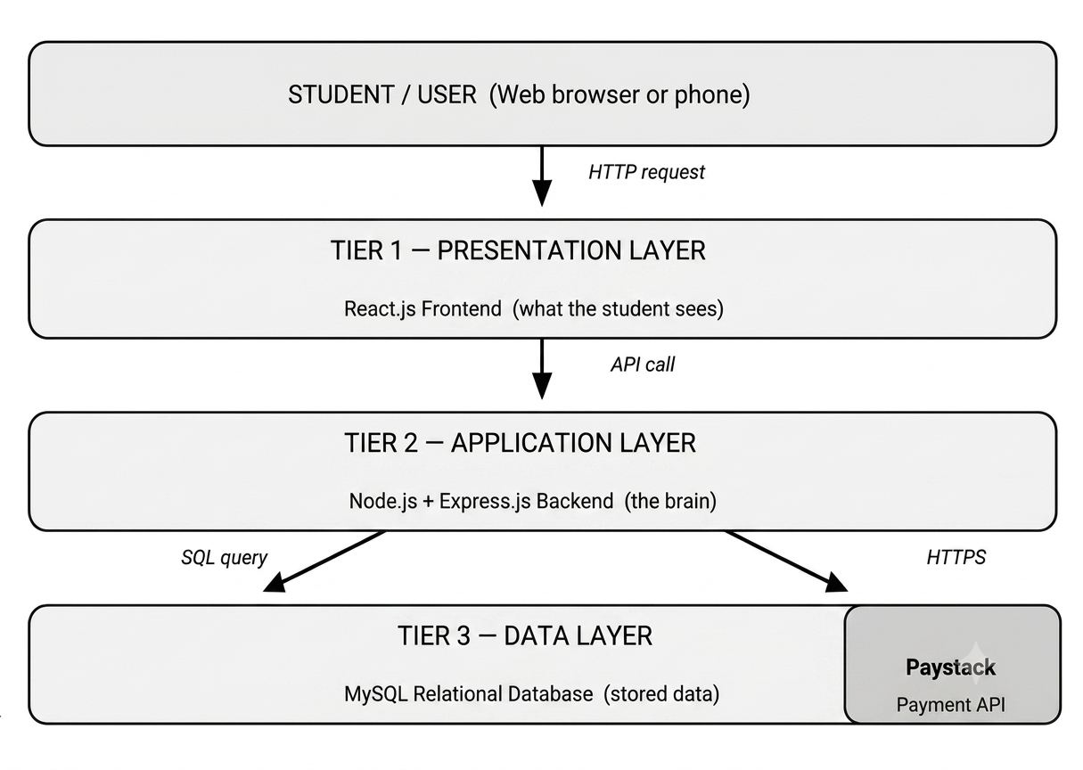

Figure 3.1 Tier Architecture

Component | Technology | What it does
Student  Interface | React.js | Builds the interactive pages the student and admin see and use
Styling | Vanilla CSS | Makes every screen look clean and work correctly on all device sizes
Backend Server | Node.js +  Express.js | Processes all requests, applies business logic, and manages data flow
Database | MongoDB | Permanently stores all users, menus, orders, cart items, and payments
Password  Safety | bcrypt | Scrambles passwords so they are unreadable even if the database is accessed
Session  Management | JSON Web Tokens  (JWT) | Keeps users securely logged in as they move between pages
Payments | Paystack API | Processes all card, bank transfer, and USSD payments securely
Frontend-Backe and Comms | Axios | Sends and receives data between React and the Node.js server
Code  Management | Git / GitHub | Tracks every change made to the codebase over time
Live Hosting | Render / Railway | Publishes the finished application on the internet for real users
Table 3.3.2: Technology Stack Summary

3.3.3 Design of the System

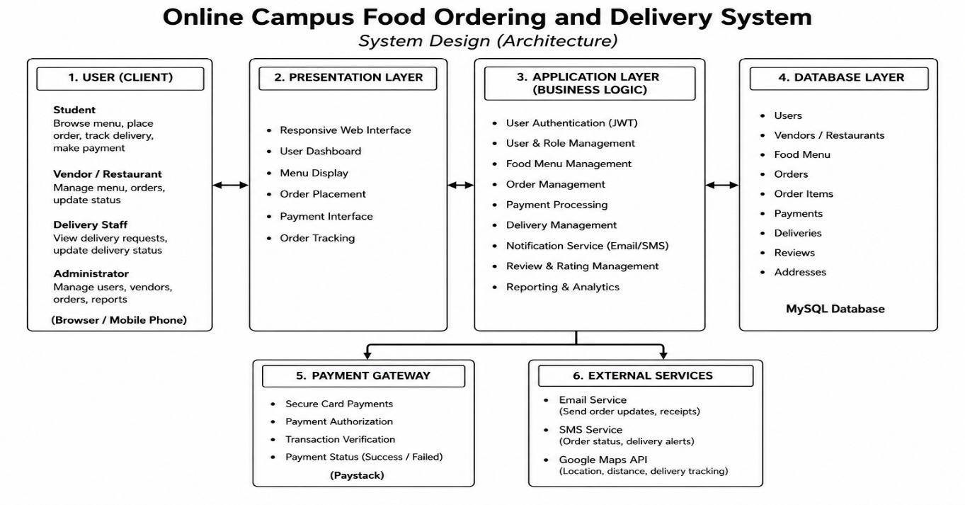

Figure 3.2 Design of the system

3.3.3 Data base Architecture

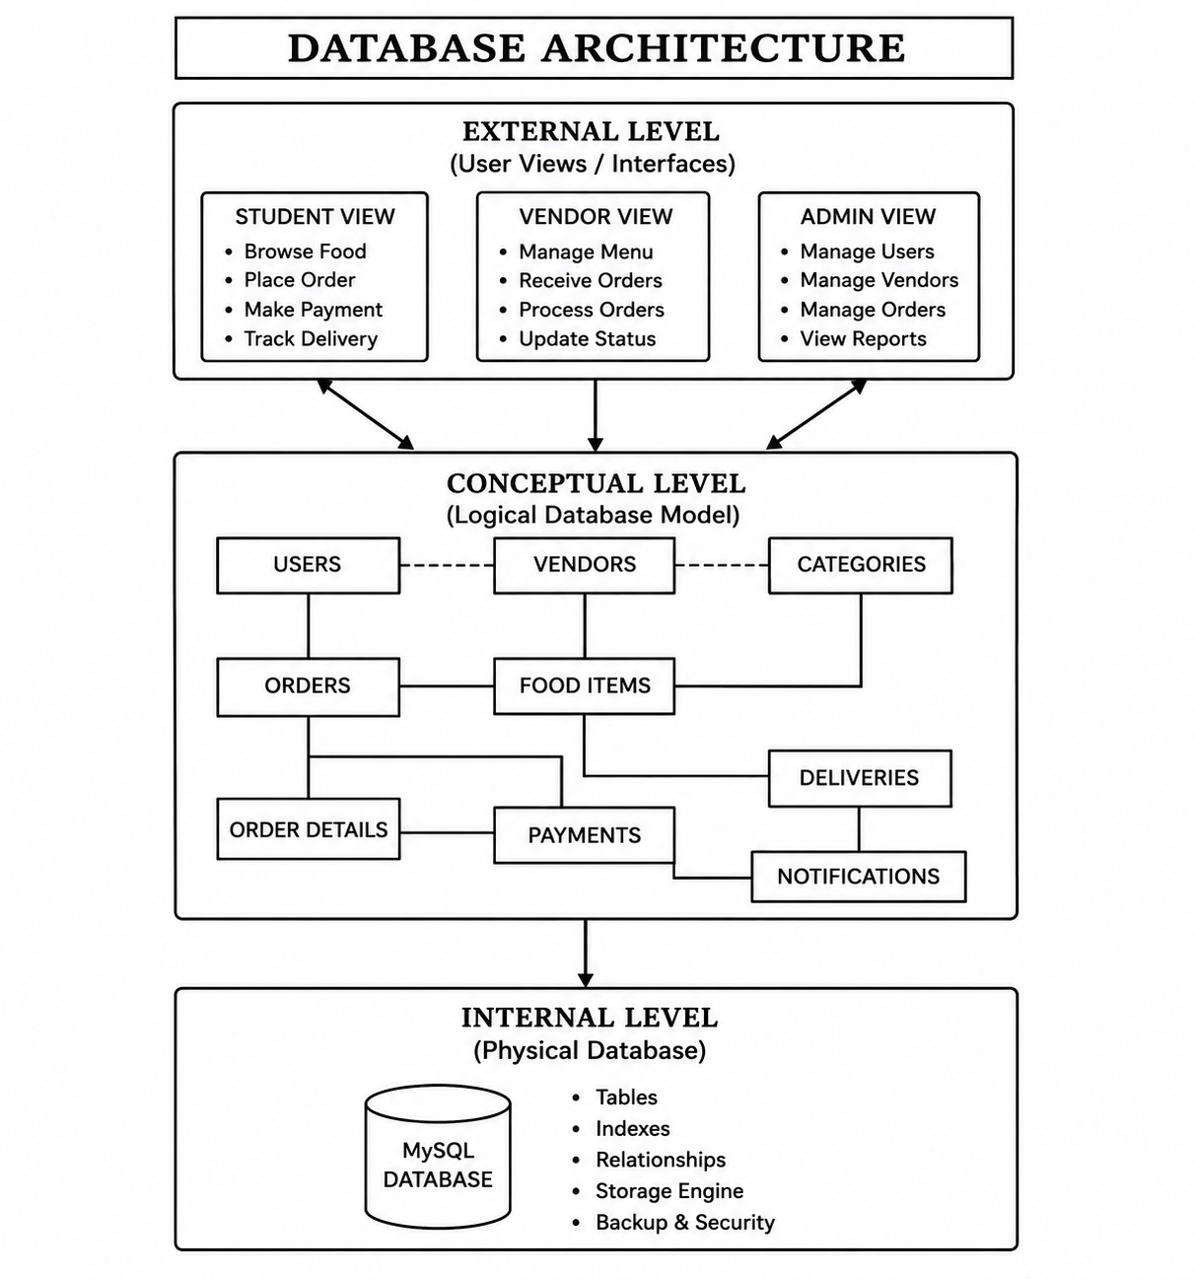

Figure 3.3:Data Base Architecture

3.3.4 Algorithm / Flowchart / Use Case Diagram
Flowcharts and use case diagrams are commonly used during system design to illustrate system processes, user interactions, and the sequence of operations within a software application (Sommerville, 2020; Dennis, Wixom, & Tegarden, 2020). To better understand how the system works, we use flowcharts and a use case diagram. After a successful login, the admin reaches the dashboard overview. From there, they have three paths: managing the menu (adding, editing, or removing meals), generating reports (getting a sales summary for any date range), or processing orders (the most frequent task). For each new order, the admin reviews the full details, prepares the food, and advances the status step by step until the order is marked as Delivered. Payment is recorded automatically by the system once Paystack has confirmed the transaction

A. System Flowchart — Student Food Ordering Process
START
▼
Student Registers / Logs In
▼
Student Browses Food Menu
▼
Student Adds Items to Cart
▼
Student Reviews Cart & Confirms Order
▼
Student Makes Online Payment (Paystack)
▼
Payment Successful?
▼
Order Confirmed & Sent to Kitchen
▼
Student Tracks Order Status
▼
Food Delivered / Ready for Pickup
▼
END
Figure 3.3: Flowchart of the Student Food Ordering Process

B. Admin/Cafeteria Staff Flowchart

START
▼
Admin Logs Into Dashboard
▼
View Incoming Orders
▼
Is there a new order?
▼
Accept Order & Update Status to 'Preparing'
▼
Food is Prepared
▼
Update Status to 'On the Way' or 'Ready'
▼
Order Delivered to Student
▼
Mark Order as 'Completed'
▼
END
Figure 3.4: Flowchart of the Admin/Cafeteria Staff Process

C. Use Case Diagram (Described)
A use case diagram shows all the different types of users (called "actors") and what they can do in the system. For our Online Campus Food Ordering and Delivery System, there are three main actors:
1. Student (Customer): The person who orders food.
2. Admin (Cafeteria Staff): The person who manages the menu and processes orders.
3. System (Paystack): The payment gateway that handles transactions automatically.

Use Cases for Student:
1. Register/Create Account
2. Login to Account
3. Browse Menu
4. Search for Food
5. Add Item to Cart
6. Place Order
7. Make Payment
8. Track Order
9. View Order History
10. Logout

Use Cases for Admin:
1. Login to Admin Dashboard
2. Add / Edit / Delete Menu Items
3. View All Orders
4. Update Order Status
5. View Sales Report
6. Manage Users

Use Cases for Paystack (System):
1. Verify Payment
2. Send Payment Confirmation
3. Handle Failed Transactions

3.3.4 Advantages of the Proposed System
The new Online Campus Food Ordering and Delivery System solves all the problems we found with the old manual system. Here are the key advantages:
      - Saves Time: Students no longer need to walk to the cafeteria. They can order food in seconds from their phones or laptops, even from their hostel room or classroom.
      - No More Long Queues: Because orders are placed online and spread out over time, there are fewer people crowding the cafeteria at once. This means less stress for both students and staff.
      - Order in Advance: Students can place their orders before they are even hungry, ensuring their food is ready when they need it.
- Multiple Payment Options: The system supports online payments through Paystack, so students don't have to carry cash. They can pay with their bank card or mobile bank app.
- Real-Time Order Tracking: Just like tracking a package, students can see exactly what is happening with their order whether it's being prepared, on the way, or ready for pickup.
- Accurate Orders: Since orders are submitted digitally, there is no confusion or miscommunication. The cafeteria staff see exactly what was ordered.
- Menu Always Available Online: Students can check what is available at any time without leaving their rooms. They can plan their meals ahead.
- Order History: Students can see all their past orders and quickly reorder their favourite meals.
- Better Management for Staff: The admin dashboard helps cafeteria staff stay organized, manage inventory better,and handle many orders at once without confusion.
- Delivery to Any Location on Campus: Students who are sick, busy with assignments, or in a lecture can have their food delivered directly to them.
- Secure and Reliable: All data is stored safely in a database, and payments are handled securely through Paystack's verified payment infrastructure.

3.4 Database Design and Specification
The database is where every single piece of information in the system is permanently stored and kept safe. Think of it as the filing room that sits behind the whole operation. Every student who registers, every meal listed on the menu, every order ever placed, and every payment ever made ends up as a record in this database. A poorly designed database causes the entire application to malfunction data gets lost, records become inconsistent, and the system starts producing wrong results. Getting the database design right is therefore just as important as writing the application code.
MongoDB was chosen as the database management system for this project. It is free, open-source, and has been trusted in real-world web applications around the world for decades. It organises data into tables structured, row-by-row storage and connects those tables to each other through rules called References. This makes both data retrieval and data integrity straightforward to manage. MongoDB also integrates cleanly with the Node.js backend through a connector library called MongoDB2 (Elmasri & Navathe, 2017).
The database is made up of five collections. Each one is described below with a plain-English explanation of what it does, followed by a complete specification of every field it contains

3.4.1 Users Collection
The Users Collection stores account information for every person on the platform — both students ordering food and administrators managing it. It is the most central table in the database because almost every other table links back to it. When a student registers, a new row appears here. When they log in, this table is checked to confirm who they are. The role field is what determines whether the system shows someone the student ordering view or the admin dashboard

Field Name | Data Type | Constraints | What It Stores / Why It Matters
userId | INT | REQUIRED, UNIQUE, | Unique number assigned automatically to every new user when they register
name | VARCHAR(100) | NOT NULL | The user's full name exactly as they typed it during registration
email | VARCHAR(150) | NOT NULL,  UNIQUE | Email address used to log in; no two accounts can share the same email
userId | VARCHAR(20) | UNIQUE, NULL | Student matric number; set to NULL (empty) for administrator accounts
password | VARCHAR(255) | NOT NULL | The scrambled (hashed) version of the password — plain text is never stored
role | ENUM  (‘student’,’staff’,’kitchen’,’admin’) | NOT NULL,  DEFAULT 'student' | Controls what the user can see: student ordering features or the admin panel
phone_number | VARCHAR(15) | NULL | Optional phone number for use in delivery coordination
is_active | TINYINT(1) | DEFAULT 1 | 1 means the account is active; 0 means an admin has deactivated it
created_at | TIMESTAMP | DEFAULT CURR ENT_TIMESTAMP | The exact date and time the account was created

3.4.2 MenuItems Collection
The Food Items table is the digital version of the menu. Every meal a vendor makes available for ordering is stored as one row in this table. Vendors can add new meals, update prices, rewrite descriptions, swap photos, or temporarily hide items using the is_available flag — setting it to 0 makes the item invisible to students without deleting it permanently. Setting it back to 1 makes it visible again instantly.

Field Name | Data Type | Constraints | What It Stores / Why It Matters
food_id | INT | REQUIRED, UNIQUE | Unique number assigned to each food item in the catalogue
name | VARCHAR(100) | NOT NULL | The meal name as it appears on the student menu (e.g. Jollof Rice, Fried Chicken)
description | TEXT | NULL | A short description of the meal's contents or portion size
price | DECIMAL(10,2) | NOT NULL | Price of the meal in Nigerian Naira, stored with exactly two decimal places
category | VARCHAR(50) | NOT NULL | The menu group this meal belongs to: Rice Dishes, Protein, Soups, Drinks, or  Snacks
image_url | VARCHAR(255) | NULL | The web address or file path of the meal's display photo
is_available | TINYINT(1) | NOT NULL,  DEFAULT 1 | 1 = visible and in stock; 0 = temporarily hidden from students
vendor_id | INT | REFERENCE →  Users(userId) | Links this food item to the administrator account responsible for it
created_at | TIMESTAMP | DEFAULT CURRENT_TIMESTAMP | The date and time this meal was first added to the system

3.4.3 : Orders Collection
Imagine a student who orders Jollof Rice, a chicken piece, and a bottle of water — all in a single transaction. The Orders table stores just one row for the whole order. The Orders Collection stores one separate row for each individual meal inside that order. This design is called a junction table, and it is the mechanism that makes it possible for one order to contain many different food items. The unit_price column records the price of each meal at the exact moment it was ordered, so that historical records stay accurate even if the vendor changes that meal's price weeks later.

Field Name | Data Type | Constraints | What It Stores / Why It Matters
item_id | INT | REQUIRED, UNIQUE | Unique identifier for each individual meal line within an order
order_id | INT | NOT NULL,  REFERENCE →  Orders(order_id) | Links this line item to the parent order it belongs to
food_id | INT | NOT NULL,  REFERENCE →  FoodItems(food_id) | Identifies exactly which meal was ordered on this line
quantity | INT | NOT NULL,  CHECK (quantity> 0) | How many units of this meal were ordered — must be at least 1
unit_price | DECIMAL(10,2) | NOT NULL | Price of this specific meal at the exact moment the order was placed — locked for historical accuracy
Table 3.4: Orders Collection

3.4.4: Orders Collection
The Orders Collection is the financial ledger of the system a permanent, tamper-resistant record of every payment transaction. The paystack_ref column stores the unique transaction code that Paystack generates for every payment, which can be used to verify or dispute any transaction directly with Paystack. The UNIQUE constraint on the order_id column makes it physically impossible for the database to record two different payments for the same order, which completely prevents accidental double-charging

Field Name | Data Type | Constraints | What It Stores / Why It Matters
payment_id | INT | REQUIRED, UNIQUE | Unique identifier for each payment transaction record
order_id | INT | NOT NULL,  UNIQUE,  REFERENCE →  Orders(order_id) | Links to the order being paid for; UNIQUE ensures only one payment can exist per order
paystack_ref | VARCHAR(100) | NOT NULL, UNIQUE | The unique transaction reference code issued by Paystack for every payment
amount | DECIMAL(10,2) | NOT NULL | The exact amount charged to the student in Nigerian Naira
payment_status | ENUM(...) | NOT NULL, DEFAULT  'Pending' | Pending = awaiting confirmation; Paid = successful; Failed = declined or error
payment_method | VARCHAR(50) | NULL | How the student paid: card, bank_transfer, or ussd
paid_at | TIMESTAMP | NULL | Date and time Paystack confirmed the payment succeeded; stays empty until then

Table 3.5: Orders Collection

3.4.5: Cart (Frontend)
The Cart (Frontend) is a student's temporary shopping basket a holding area for meals they have selected but have not yet committed to ordering. Unlike the Orders Collection, which records confirmed and paid purchases, the Cart is completely fluid: items can be added, removed, or changed in quantity right up until the moment the student clicks checkout. The instant a student confirms their order and payment succeeds, all of their cart entries are automatically deleted, leaving the cart clean and ready for the next shopping session

Field Name | Data Type | Constraints | What It Stores / Why It Matters
cart_id | INT | REQUIRED, UNIQUE | Unique identifier for each individual cart entry
userId | INT | NOT NULL,  REFERENCE →  Users(userId) | Identifies which student this cart entry belongs to
food_id | INT | NOT NULL,  REFERENCE →  FoodItems(food_id) | Identifies which meal has been placed in the cart
quantity | INT | NOT NULL,  CHECK (quantity> 0) | How many of this meal the student wants — must be at least 1
added_at | TIMESTAMP | DEFAULT CURRENT_TIMESTAMP | The date and time this meal was added to the cart
Table 3.6: Cart (Frontend)

3.4.6: Database Relationship
The five collections in this database are not isolated from each other — they are linked together through Reference relationships. A Reference is a field in one table that points directly to the Required, Unique of another table, creating a permanent and enforced connection between the two. These links are what allow the system to answer questions like 'show me all orders from this student' or 'what meals were inside order number 47'. They also protect the data — it is technically impossible to save a record that references something which does not exist in the referenced table (Elmasri & Navathe, 2017).
- Users → Orders (One-to-Many): A single student can place as many orders as they like over the entire lifetime of their account. But every individual order belongs to exactly one student. The userId Reference in the Orders table enforces this. It is impossible to have an order record that does not belong to a specific, identifiable registered user.
- Orders → Order Items (One-to-Many): A single order can contain many different meals — for example, rice, chicken, and a drink all purchased together. But every individual order item line belongs to exactly one order. The order_id Reference in the Orders Collection creates and enforces this parent-child relationship.
- Food Items → Order Items (One-to-Many): The same food item can appear in hundreds or thousands of different orders placed by different students over time. But each individual order item line references exactly one food item. This relationship is what allows the system to know precisely which meal appeared in every past order, even years after it was placed.
- Orders → Payments (One-to-One): Every confirmed order has exactly one payment record and every payment is tied to exactly one order. This strict one-to-one relationship is enforced by a UNIQUE constraint placed on the order_id field in the Orders Collection. The result is that it is technically impossible for the database to store two payment records for the same order, which completely eliminates the risk of double-charging.
- Users → Cart (One-to-Many): A single student can have many different meals sitting in their shopping cart at the same time — for example, rice, chicken, and a drink all added separately before checkout. Every individual cart entry belongs to exactly one student. When the student places their order, all their cart entries are deleted automatically to keep the cart clean for next time.
- Food Items → Cart (One-to-Many): The same food item can exist in many different students' carts simultaneously — for example, Jollof Rice might be in the carts of thirty students at the same moment. Each individual cart entry still references exactly one food item. This relationship lets the system track which specific meals are in which specific student's cart at any given moment.

CHAPTER FOUR
RESULTS AND DISCUSSION

4.1 System Requirements
Before any code was written, it was necessary to settle on the tools and environment that would support both development and eventual deployment of the system. The choices below were guided mainly by cost (the project had no budget for paid licences), the need for something a single developer could realistically maintain, and compatibility with the campus internet environment students at Federal University Otuoke typically use.
4.1.1 Software Requirements
The following software tools and technologies were used in building FUO Eats:
- Operating System – Windows 10/11 was used during development, though the deployed application is platform-independent since it runs in a browser.
- Frontend – React.js (JavaScript library) alongside HTML5, CSS3 and JavaScript (ES6+) for building the user interface consumed by students placing orders.
- Backend – Node.js as the runtime environment, with Express.js handling routing, middleware and API endpoints.
- Database – MongoDB, chosen over a heavier system like MongoDB because it needed no separate database server and kept the project self-contained for a single machine.
- Authentication – JSON Web Tokens (JWT) for securing admin routes and protecting order/menu management endpoints from unauthorised access.
- Payment Gateway – Paystack API, integrated to handle credit and debit card transactions in place of the cash-on-delivery model common on campus.
- Code Editor – Visual Studio Code, used for writing and debugging both frontend and backend code.
- Version Control – Git, for tracking changes across the several iterations the project went through.
- API Testing – Postman, used to test backend endpoints independently of the frontend before wiring them together.
- Browsers – Google Chrome and Microsoft Edge were the primary browsers used for testing responsiveness and cross-browser behaviour.
It is worth noting that no single one of these tools was fixed from the outset. Earlier iterations of the project, for instance, used plain HTML, CSS and JavaScript before the frontend was consolidated into React components, and the backend only gained a proper database layer once the limits of storing data in memory became obvious during testing.
4.1.2 Hardware Requirements
FUO Eats was designed to run comfortably on modest hardware, in keeping with the kind of devices students and campus vendors are realistically likely to own. Table 4.1 summarises the minimum hardware specifications for both the development/server side and the client side.
Component | Specification
Processor | Intel Core i3 (2.0 GHz) or higher
RAM | 4 GB minimum (8 GB recommended for development)
Storage | At least 20 GB of free disk space
Network | Stable internet connection (minimum 1 Mbps) for API calls and payment verification
Client Device | Any smartphone, tablet, or PC with a modern web browser
Display | Minimum resolution of 720p for comfortable viewing of the interface
Table 4.1: Minimum Hardware Requirements
4.2 Testing of the Proposed System
FUO Eats is not a machine-learning based application, so there was no training phase in the sense of a model learning from data. What applies here instead is testing — making sure each part of the system behaves as expected before it is trusted to handle real orders and real payments. Four levels of testing were carried out during development.
Unit Testing
Individual functions were tested in isolation as they were written — for example, the cart logic that calculates subtotals, the function that validates a matriculation number format, and the middleware that checks whether a JWT token is valid before allowing access to admin routes. Bugs caught at this stage were far cheaper to fix than ones discovered later.
Integration Testing
Once individual pieces worked on their own, they were tested together. This meant confirming that an order placed on the frontend actually reached the Express backend, was correctly written to the MongoDB database, and triggered the right response back to the user, rather than each piece simply working in isolation.
System Testing
The complete application was tested end-to-end: browsing the menu, adding items to a cart, checking out, paying through Paystack's sandbox/test environment, and confirming the order appeared correctly on the admin dashboard. This stage surfaced issues that only show up when modules interact under realistic conditions, such as a cart total not refreshing after an item was removed.
User Acceptance Testing (UAT)
A small number of students and a mock 'vendor' account were asked to use the system as they would in practice — placing an order, cancelling one, and attempting to log in as an admin without the right credentials. Their feedback informed small interface adjustments, particularly around making the checkout button more obvious and clarifying error messages when a card payment failed.
4.3 Customer/User Module
This is the module a student interacts with first. It covers account access, browsing the available food vendors and menus, managing a cart, and placing an order.
On opening the application, a student is presented with a homepage listing available campus food vendors, styled using FUO's official colours so that the platform feels distinctly tied to the university rather than a generic food app. From there, a user can browse menu items by vendor, view prices, and add selected items to a cart. The cart component keeps a running total and allows quantities to be adjusted or items removed before checkout.
Checkout requires the student to confirm a delivery location on campus (a hostel or department building, for instance) before being routed to payment. This is where the Paystack integration comes in, discussed further in section 4.5. Once payment is confirmed, an order confirmation screen is displayed and the order is written to the database with a status of 'pending', ready to appear on the vendor/admin side.

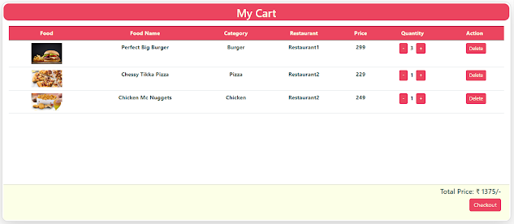

Plate 4.1: cart interface
4.4 Admin/Vendor Module
The admin module is where a vendor or system administrator manages what the customer-facing side displays. Access to this module is restricted using JWT-based authentication, meaning a valid token issued at login must accompany every request to an admin route; without it, the Express backend rejects the request outright.
From the admin dashboard, an authenticated user can add new menu items, edit prices, mark items as out of stock, and view a list of incoming orders in real time. Orders can be updated through a simple lifecycle pending, in progress, and delivered — so that both the vendor and, eventually, the student have visibility into where an order stands. A basic sales overview was also added, summarising the number of orders and total revenue processed within a given period, which proved useful during testing for spotting whether transactions were being recorded correctly.

4.5 Payment and Order Processing Module
This module ties the customer and admin sides together and is arguably where the most care was needed, since it involves real money, even in the test/sandbox stage. Paystack was chosen because it is widely used in Nigeria, supports card payments directly, and provides a well-documented API with a test mode that made it possible to simulate transactions without financial risk during development.
When a student proceeds to pay, the frontend initialises a Paystack transaction and redirects to Paystack's secure payment page, meaning card details are never handled directly by the FUO Eats server an important security consideration given that the system was not going to undergo formal PCI-DSS certification. After payment, Paystack sends a response that the backend verifies against Paystack's servers before marking the order as paid, rather than trusting the frontend's word for it. This verification step was added specifically after early testing showed that relying on a client-side success message alone left room for the order to be marked paid even when a transaction had actually failed or been abandoned.

4.6 Result Discussion
Testing across the modules described above showed that the core objective of the project allowing a student to order food from a campus vendor and pay by card without needing to be physically present was achieved. Orders placed through the customer module were reliably reflected on the admin dashboard within seconds, and the JWT-protected routes correctly blocked attempts to access admin functionality without a valid token, which had been a specific concern going into testing.
The Paystack integration performed as expected under test conditions, correctly distinguishing between successful, failed, and abandoned transactions. This was not the case in an earlier version of the payment flow, where a network delay could leave an order stuck in an ambiguous state; adding server-side verification, as described in section 4.5, resolved this. Response times for typical actions adding an item to the cart, submitting an order, loading the admin dashboard stayed under two seconds on a standard broadband connection during testing, though this was not measured under the kind of concurrent load a live deployment with many simultaneous users would produce.
A few limitations became apparent during this process. First, the use of MongoDB, while convenient for a single-developer project of this scale, would likely need to be replaced with a more robust database such as PostgreSQL if the system were to support multiple vendors and a larger student population concurrently. Second, delivery logistics matching an order to an actual delivery agent on campus was outside the scope of what was implemented; the system currently records a delivery location but does not manage a delivery workforce. Third, testing was conducted primarily by the researcher and a small group of volunteers rather than a representative sample of the student population, so some usability issues may not yet have surfaced.
On balance, the results suggest that the system fulfils the requirements set out in Chapter One and demonstrates that a campus-specific, card-enabled food ordering platform is technically feasible to build and operate on modest infrastructure. The next chapter draws these findings together and considers what would be needed to move FUO Eats from a working prototype to a system ready for actual use on campus.

References
Davis, F. D. (1989). Perceived usefulness, perceived ease of use, and user acceptance of information technology. MIS Quarterly, 13(3), 319–340. doi:10.2307/249008
Dennis, A., Wixom, B. H., & Tegarden, D. (2020). Systems analysis and design: An object-oriented approach with UML (6th ed.). Hoboken, NJ: John Wiley & Sons. Retrieved from https://www.wiley.com/
EDUCAUSE. (2020). 2020 EDUCAUSE Horizon Report: Teaching and Learning Edition. Retrieved from https://library.educause.edu/resources/2020/3/2020-educause-horizon-report-teaching-and-learning-edition
Elmasri, R., & Navathe, S. B. (2017). Fundamentals of database systems (7th ed.). Boston, MA: Pearson. Retrieved from https://www.pearson.com/
Kendall, K. E., & Kendall, J. E. (2019). Systems analysis and design (10th ed.). Harlow, England: Pearson. Retrieved from https://www.pearson.com/
Kimes, S. E. (2011). The future of distribution management in the restaurant industry. Journal of Revenue and Pricing Management, 10(2), 189–194. doi:10.1057/rpm.2011.1
Laudon, K. C., & Laudon, J. P. (2022). Management Information Systems: Managing the Digital Firm (17th ed.). Boston, MA: Pearson. Retrieved from https://www.pearson.com/en-us/subject-catalog/p/management-information-systems-managing-the-digital-firm/P200000003479
PCI Security Standards Council. (2022). Payment Card Industry Data Security Standard (PCI DSS) Version 4.0. Retrieved from https://www.pcisecuritystandards.org/document_library
Pressman, R. S., & Maxim, B. R. (2020). Software engineering: A practitioner's approach (9th ed.). New York, NY: McGraw-Hill Education. Retrieved from https://www.mheducation.com/
Ray, A., Dhir, A., Bala, P. K., & Kaur, P. (2019). Why do people use food delivery apps (FDA)? A uses and gratification theory perspective. Journal of Retailing and Consumer Services, 51, 221–230. doi:10.1016/j.jretconser.2019.05.025
Sommerville, I. (2020). Software engineering (10th ed.). Harlow, England: Pearson. Retrieved from https://www.pearson.com/
Turban, E., Pollard, C., & Wood, G. (2018). Information Technology for Management: Driving Digital Transformation to Increase Local and Global Performance, Growth and Sustainability (11th ed.). Hoboken, NJ: Wiley. Retrieved from https://www.wiley.com/en-us/Information+Technology+for+Management%3A+Driving+Digital+Transformation+to+Increase+Local+and+Global+Performance%2C+Growth+and+Sustainability%2C+11th+Edition-p-9781119473747
Unified Theory of Acceptance and Use of Technology Venkatesh, V., Morris, M. G., Davis, G. B., & Davis, F. D. (2003). User acceptance of information technology: Toward a unified view. MIS Quarterly, 27(3), 425–478. https://doi.org/10.2307/30036540
Venkatesh, V., Morris, M. G., Davis, G. B., & Davis, F. D. (2003). User acceptance of information technology: Toward a unified view. MIS Quarterly, 27(3), 425–478. doi:10.2307/30036540 (trentu.ca)
World Wide Web Consortium. (2023). Web Content Accessibility Guidelines (WCAG) 2.2. https://www.w3.org/TR/WCAG22/

